

The larynx or “voice box” is at the back of the throat. It not only creates the voice, but protects the lungs from liquids or food from entering.   
Older, large breed dogs can develop paralysis of one or both of these vocal folds.   
This will either close off the airway or leave it open. When closed, the airway is smaller making it more difficult for a dog to breathe and to pant and cool themselves. If stuck open, the dog is vulnerable to aspiration of liquids, foods into the lungs, where pneumonia develops.   
We hear and increased noise when these dogs breathe and more panting even when it is cooler.

There is no good treatment for this disease and the paralysis rarely improves.

These dogs need to be indoors in warm weather with LOTS of water available. Without being able to pant and cool themselves heat stroke can happen in minutes!

**Laryngeal Paralysis**

**Grass Seed Season**

Grass seeds are expertly designed to move in one direction and plant themselves into the ground.

Unfortunately, they also burrow themselves into the skin or the feet, armpits, eyelids and ears!

When these seeds get into dogs’ ears, we have to sedate the dog in order to remove them safely. The seeds often press right against the ear drum and can puncture through if not treated quickly and correctly.

**Watch for head shaking, scratching at ears. Redness of the skin- especially feet are another common location!

**Steer clear of tall, uncut grass to prevent problems!

Call if you are concerned about grass seeds and your pet!

**www.bestfriendsanimalhealthcenter.com**

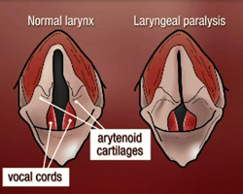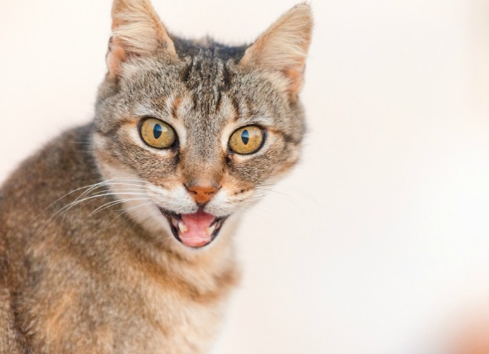

**CLOSURE! We will be closed from 10AM to 2PM on Monday, August 21st for the Eclipse.   
Please call if you have a pet emergency, we will be available to help.**

**Did you know cats can have asthma?   
Especially in this hot, dry, smoky weather we can see cats have difficulty breathing. Cats should NEVER breathe with their mouths open. This is a sign of stress or inability to breathe. We can also see cats breathe using their abdominal muscles. If you see any of these signs in your cat. Bring them in right away!**